Note: how to read SQL syntax diagrams.

Don't be intimidated by the seeming complexity. Here are a few simple rules to interpreting them:
- Start at the point on the left, move right.
- ALL CAPS are literal SQL key-words. Lower-case are descriptions of what should go there.
- Rectangles indicate some statement that has its own documentation someplace else (and is replaced with the rectangle for brevity).
- If the path is along a straight line, that is the default invocation of that type of statement. Paths deviating from a main path and then rejoining it are optional alternatives to the default invocation. Alternatives can have their own alternatives.
- If there are several parallel paths all branching from the main one, you have to choose one of them.
- If a path loops around in a circle, that means the clause it contains can be repeated multiple times.
- Sometimes there is a really long path. To save space, it will curve around to the left margin and then continue. That has no particular meaning.

Ironically, the reason for doing this is that SQL syntax is (in some senses) simple. For the types of SQL statements below, each possible statement of that type is completely explained by the accompanying diagram (except the one for debugging, because on the right side it just branches off into each of the other possible SQL statements, so I cut that part off). If you tried to represent R or C++ in this way, you could, but the diagrams would be much harder to understand.

Function | SQL Language Syntax
Comment | 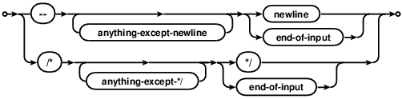
Variable assignment | /* Using the term loosely to mean 'chunk of data, we have this...*/  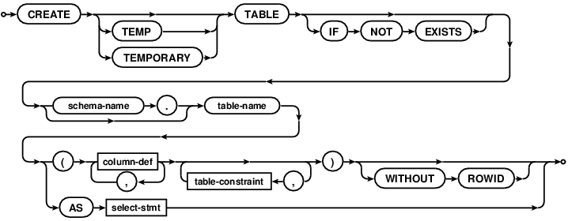  /* to change values, this */  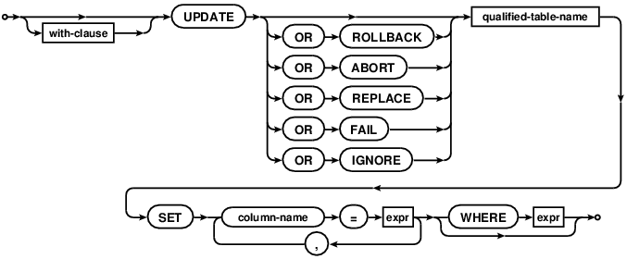  /* to add values, this */  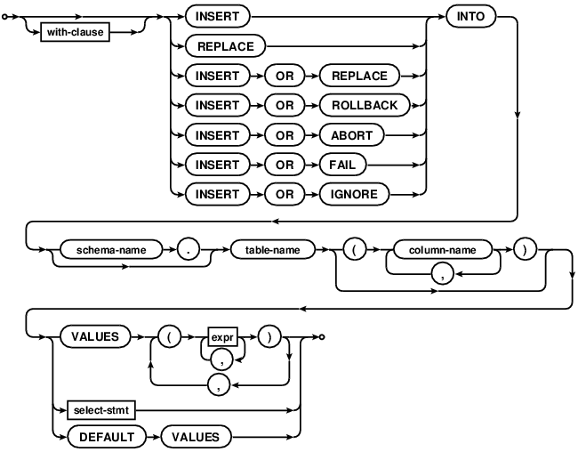  /* to delete values, this */  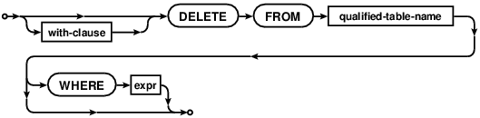
Get help | /* depends on SQL variant. For SQLite it's...*/  .help  /* ...but that's for special commands. In most  cases the way to get help is through Google */
Arithmetic: add, subtract, multiply, divide, exponent, modulo (remainder) | foo + bar  foo - bar  foo * bar  foo / bar  /* No exponent function! But, see this. */  foo % bar;
Controlling order of operations | foo * (bar + baz) / (bat - bax)
Using functions | foo(bar, baz)
Multiple expressions on the same line | foo ; bar; bat;
Logical operators (return TRUE or FALSE): equal, unequal, greater than, less than, greater than or equal, less than or equal | foo == bar; foo = bar;  foo != bar; foo <> bar;  foo > bar;  foo < bar;  foo >= bar;  foo <= bar;
Conditional statements | /* within a select */  CASE WHEN foo=1 THEN 'A' WHEN foo=2 THEN 'B' ELSE 'Z' END  /* when creating a table */  CREATE TABLE IF NOT EXISTS
For loop | /* most closely approximated by a WHERE clause */  WHERE foo=bar;
While loop | N/A /* though there is a RECURSIVE keyword in some SQL variants including the latest SQLite */
Print | select 'foo'; select 3+5;
Plot graphics | N/A  /* SQLiteStudio will probably generate diagrams for you. They will probably be confusing at first. Maybe eventually useful, maybe not. */
Save to a file | .header on  .mode csv  .once foo.csv  SELECT * FROM bar;
Read from file (or clipboard) | .mode csv  .import foo.csv bar;  /* where foo is a .csv file and bar is a table */
Quoting: the character string foo, vs the name foo, vs the value of the foo variable | select 'foo';  select `foo`; select foo;  /* some SQL variants can read a SQL string and interpret it within a stored procedure (this technique is called dynamic SQL). SQLite cannot, depends on some language to pull text out of it and then return it as an executable command */
Create your own function | /* In SQLite this job is done by whatever language is interacting with it (e.g. Java, R, Python, etc.). In other SQL variants this is done by stored procedures. */
Debugging | 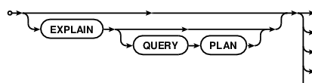
Data structures and subscripting: picking out specific entries within vectors, matrices, lists | 